# Beam Deflection Curves from Concentrated Static Offset Loads

Christopher Shieh

Revised 6/30/2020

Structures on the moon are subject to many hazardous conditions that we do not face on earth such as moonquakes, extreme temperatures and frequent micro-meteorite impacts. This paper is focused on the displacement a beam will experience when impacted off center.

In these equations, a simply supported beam of 1 meter will be assumed under concentrated offset load P, distance a from point A, and b from point B. The beam will have a cross section of 0.1 meters squared and have a material modulus of 200 GPa.

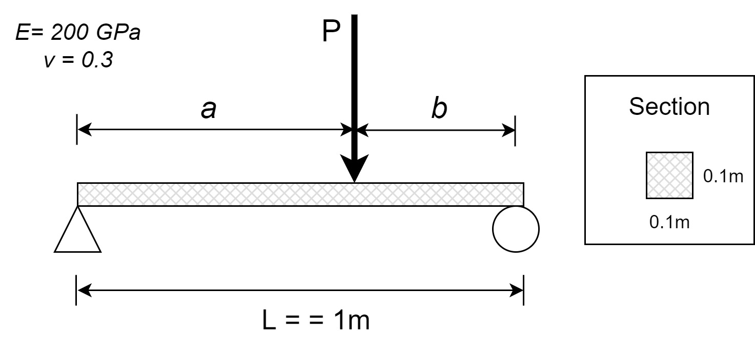

*Fig. 1*

*Diagram of an offset load applied to a simply supported beam*

To begin, a table of beam deflections [1] is referenced for the offset load deflection curve:

|  |  |  |
| --- | --- | --- |
|  | $$y= \frac{Pbx}{6LEI}(L^{2}-x^{2}-b^{2})$$ For *0* < *x* < *a* | (1) |

|  |  |  |
| --- | --- | --- |
|  | For *a* < *x* < *L* | (2) |

Due to the need for two separate equations to calculate the deflection curve, two iterations were required in MATLAB in order to create a single curve. It is possible to use a single equation to calculate the curve, but it would be limited to situations in which a<b only.

In addition to these equations for the deflection curve, equation 3 is used to calculate the distance from A to the point of maximum deflection, Xm ­[2].

|  |  |  |
| --- | --- | --- |
|  | $$X_{m}=\sqrt{\frac{L^{2}-b^{2}}{3}}$$ For *a* > *b* | (3) |

In this equation, it is shown that as load P moves to an end of the beam and b approaches zero, ­­X­m approaches $\frac{\sqrt{3}}{3}$ showing that the maximum distance that the point of maximum deflection can be from the center of the beam is roughly 0.077L.

In order to verify the accuracy of the accuracy of iterations of equations 1 and 2, the output of equation 3 can be cross referenced with the following equation for maximum displacement of an offset load.

|  |  |  |
| --- | --- | --- |
|  | $$-\frac{Pb{(L^{2}-b^{2})}^{\frac{3}{2}}}{9\sqrt{3}EIL}$$ For *a* > *b* | (4) |

Using these formulas, the following graph were generated depicting the beam with 10KN loads at thirds and quarters.

These charts show us that regardless of where the concentrated load is placed on the beam, the maximum stress is concentrated within the center 15% section of the beam.

# Conclusion

The deflection curves generated by the MATLAB code show that the maximum deflection experienced by a simply supported beam stressed with an offset static load will always be located within a section of the beam that is 0.077L from the center. This means that any reinforcements should likely be located close to the midpoint of the beam rather than closer to either of the supporting ends. In addition, an equivalent load placed in the center of the beam will result in an exponentially higher maximum deflection value.

# References

|  |  |
| --- | --- |
| [1] | S. Timoshenko, G. H. MacCullough, *Elements of Strength of Materials (3rd Edition)*, Van Nostrand Company, Inc., New York, NY, 1949. |
| [2] | F. Beer, E. Johnson, J. DeWolf, D. Mazurek, *Mechaincs of Materials Seventh Edition.* McGraw-Hill Education, New York, NY, 2015. |